Question 1: (6 marks)
Write a MyStack class in Java that implements a stack ADT, whose elements are String types.
The following functions should be incuded in the MyStack class:
- boolean isEmpty() - return true if the stack is empty, i.e. the stack contains no elements, return false otherwise.
- void clear() - clear the stack (after this method is called, the stack becomes empty).
- void push(String x) - push a string x into the stack.
- String pop() - delete and return the top element from the stack (if the stack is empty then return null string).
- void popAll() - pop and display poped element until the stack becomes empty.
Write a MyQueue class in Java that implements a queue ADT, whose elements are integer types.
The following functions should be incuded in the MyQueue class:
- boolean isEmpty() - return true if the queue is empty, i.e. the queue contains no elements, return false otherwise.
- void clear() - clear the queue (after this method is called, the queue becomes empty).
- void enqueue(int x) - enqueue value x into the queue.
- int dequeue() - delete and return the front element from the queue (if the queue is empty then return 0 value).
- void dequeueAll() - dequeue and display dequeued element until the queue becomes empty.
Write the proc() function in the Main class as follows:
- void proc(String [] a) - process a string array a according to the following pseudocode.
create a MyStack and a MyQueue objects
while(there are more strings in the string array to read)
{read a string
if a string is "*" then
pop and display the poped string on the screen
else if a string is "$" then
dequeue and display the dequeued number on the screen
else
begin
if a string is not a number then push the string into the stack
else
enqueue the number into the queue
end
}
Pop and display poped element until the stack becomes empty.
Dequeue and display dequeued element until the queue becomes empty.

As shown in this exam paper, you can download the Main.java file to test your application. This file contains proposal classes and methods for this question. You can disable some options in the main method, if you cannot complete them, but you cannot modify or add new statements in the main method. Except the main method, you can add additional members to given classes, or even you can create new classes if you see they are necessary.

You must do the following before starting:
in downloaded Main.java file
replace all # with your roll number + name + birth day + province
Fore example if your roll number is 00425, your name is Nguyen Van Hung, your birth day is
22/10/1989 and you were born in Ha Noi then you replace all # with 00425HungNV891022HN

Required output:
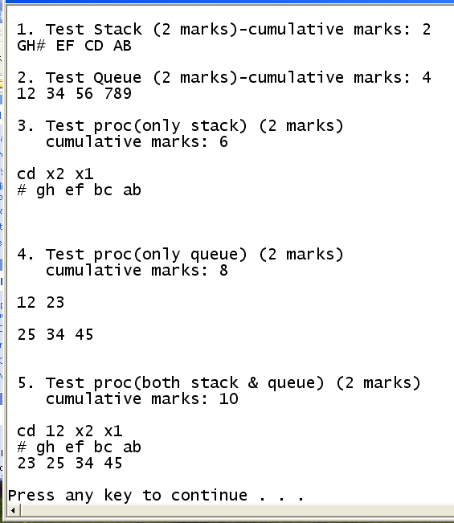
After replacing # , the output will be changed appropriately.

